YEAR 12 |  | Summer
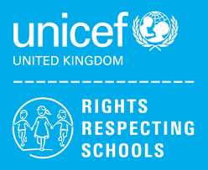 | Rights of the Child | Article 29 (goals of education) Education must develop every child’s personality, talents and abilities to the full. It must encourage the child’s respect for human rights, as well as respect for their parents, their own and other cultures, and the environment.
 | English | Functional Skills Level 1 –Exam skills and revision
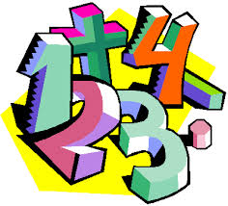 | Maths | Entry 3 Maths Skills – Shape and Space skills, coursework completion  Level 1 Maths Skills - Perimeter & Area, Data Calculations
 | Computing/ICT | Y12 L – WJEC ICT Entry Pathways E3 modules – Spreadsheet Software, Database Software, Using Email, Desktop Publishing Software
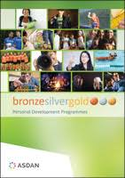 | CoPE/ YAS | Developing and demonstrating a range of personal skills by completing a choice of modules from the following:  Communication; Citizenship and Community; Sport and Leisure; Independent Living; The Environment; Vocational Preparation; Health and Fitness; Work Related Learning and Enterprise; Science and Technology; International Links; Expressive Arts; Beliefs and Values (RE)
 | Employability  Entry 3 / Level 1 | Customer Service/ Gathering Evidence for Portfolio
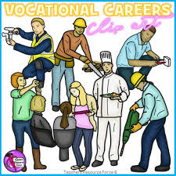 | Vocational Core | Level 1 – Researching a Topic / Gathering Evidence for Portfolio  Entry 3 – Sports Leader Award / Gathering Evidence for Portfolio
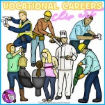 | Vocational Options  Entry 3 / Level 1 | Students will complete one vocational area each term from the following:  Gardening; Creating a Website; Catering
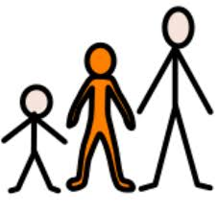 | Preparing for Adulthood | Voluntary Work/ Community Work / Work Place Tasters
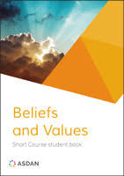 | Beliefs and Values | Inspiration
 | Skills Builder | Teamwork

