YEAR 12 |  | Summer
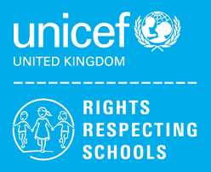 | Rights of the Child | Article 29 (goals of education) Education must develop every child’s personality, talents and abilities to the full. It must encourage the child’s respect for human rights, as well as respect for their parents, their own and other cultures, and the environment.
 | English | Functional Skills – Exam skills and revision  Exam skills
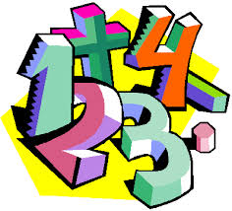 | Maths | GCSE Resit - Number, Algebra, Geometry & Measures, Ratio, Probability, Statistics, Revision and Exam Skills  Level 1 / Entry 3 – Maths skills qualification – Students will study a selection of modules from Number, 2D Shapes, Measures  Level 1 Managing Personal Finance - Bank & building society products, Advantages & disadvantages of borrowing money
 | Computing/ICT | Y12 L – WJEC ICT Entry Pathways E3 modules – Spreadsheet Software, Database Software  Y12 H - EdExcel ICT Functional Skills Level 2 Preparation
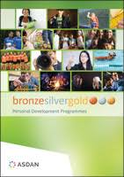 | CoPE/ YAS | Developing and demonstrating a range of personal skills by completing a choice of modules from the following:  Communication; Citizenship and Community; Sport and Leisure; Independent Living; The Environment; Vocational Preparation; Health and Fitness; Work Related Learning and Enterprise; Science and Technology; International Links; Expressive Arts; Beliefs and Values (RE)
 | Employability  Entry 3 / Level 1 | Customer Service/ Gathering Evidence for Portfolio
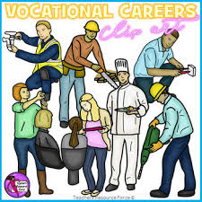 | Vocational Core | Level 1 - Being Organised / Gathering Evidence for Portfolio  Entry 3 - Team Challenge / Gathering Evidence for Portfolio
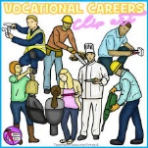 | Vocational Options  Entry 3 / Level 1 | Students will complete one vocational area each term from the following:  Animal Care; Creative Media; Catering
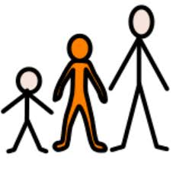 | Preparing for Adulthood | Voluntary / Community Work  Sex and Relationship Education
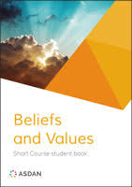 | Beliefs and Values | Inspiration

