YEAR 13 |  | Summer
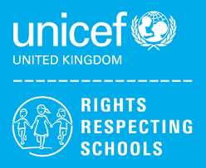 | Rights of the Child | Article 29 (goals of education) Education must develop every child’s personality, talents and abilities to the full. It must encourage the child’s respect for human rights, as well as respect for their parents, their own and other cultures, and the environment.
 | English | Functional Skills Level 1 - Exam Skills and Revision
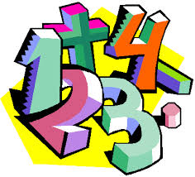 | Maths | Entry 3 Maths Skills – Decimals, Coursework completion  Level 1 Maths Skills – Perimeter & Area, Handling Data
 | Computing/ICT | Y13 L ICT – Using Email, Desktop Publishing Software, Internet Fundamentals
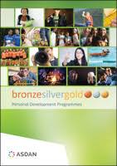 | CoPE/YAS | Developing and demonstrating a range of personal skills by completing a choice of modules from the following:  Communication; Citizenship and Community; Sport and Leisure; Independent Living; The Environment; Vocational Preparation; Health and Fitness; Work Related Learning and Enterprise; Science and Technology; International Links; Expressive Arts; Beliefs and Values (RE)
 | Employability | Level 1 – Job Searching Skills / Gathering Evidence for Portfolio  Entry 3- Making and Receiving Calls / Gathering Evidence for Portfolio
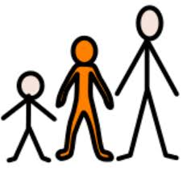 | Preparing for Adulthood | Health & Wellbeing/Travel/Work Experience

