YEAR 8 |  | Summer
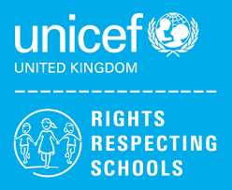 | Rights of the Child | Article 29 (goals of education) Education must develop every child’s personality, talents and abilities to the full. It must encourage the child’s respect for human rights, as well as respect for their parents, their own and other cultures, and the environment.
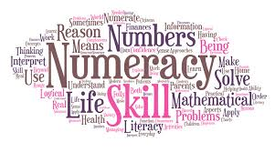 | Numeracy | Money
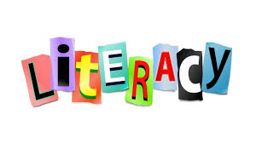 | Literacy | Homophones
 | English | 8MS Non-Fiction  8RF & 8JO –Poetry from other cultures
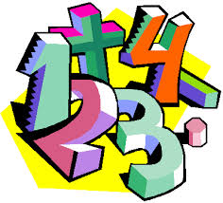 | Maths | 8RF – Fractions & Percentages, Probability  8JO - Shape, Data + Measures, Fractions + Decimals  8MS - Measurement: Length & Height, Geometry: Position & Direction, Measurement: Time, Measurement: Mass, Capacity & Temperature
 | Science | Rocks, Earth & Space, Breathing & Respiration, Unicellular Organisms
 | Computing/ICT | Spreadsheet Modelling – Costing a real-life business (Snack Bar), Data Handling – Super Heroes
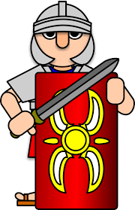 | History | The Industrial Revolution
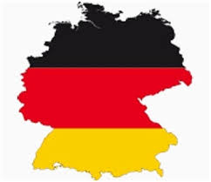 | MFL | German:  On Our Travels/Freizeit (Freetime)/Stadt und Land (Urban and Countryside)
 | Geography | Tectonics and Ecosystems
 | P.E. | Rounders, Tag rugby, Athletics, Tennis
 | Design Tech | Desk tidy, Electronic Game
 | Food Tech | 8JO - Local Food Establishments/ Healthy Living
 | Art | Stained Glass Windows
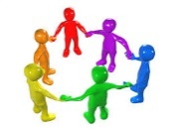 | PHSCE | Health and Wellbeing – managing change and loss  Living in the wider world – Tackling discrimination  Careers – STEM Employer Talk
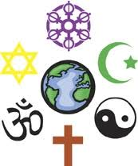 | RE | How do people show they belong to a faith?
 | Music | Variations In music
 | Independent Living | Transport  Knowledge of Community Services  Legal Issues  Emergency and Safety Skills
 | Skills Builder | 8MS- Teamwork  8RF – Leadership  8JO – Problem Solving

