YEAR 11 |  | Summer
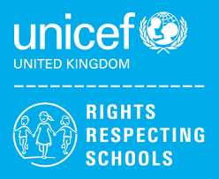 | Rights of the Child | Article 29 (goals of education) Education must develop every child’s personality, talents and abilities to the full. It must encourage the child’s respect for human rights, as well as respect for their parents, their own and other cultures, and the environment.
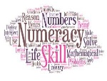 | Numeracy | Money
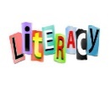 | Literacy | Homophones
 | English | 11RS – Functional Skills Level 1 – Speaking and Listening  11LQ – GCSE Revision and Exam skills
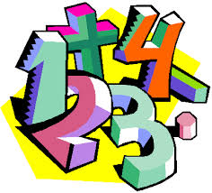 | Maths | 11RS – Working with Whole Numbers, Coursework completion, prepare for 6th form Maths / Maths for life  11LQ – Number, Algebra, Geometry & Measures, Ratio, Probability, Statistics, Exam Skills and Revision
 | Science | GCSE Waves, Magnetism and Electromagnetism, Using Resources  ELC Revision and science exams and completion of coursework
 | Computing/ICT | 11LQ – EdExcel Functional Skills Level 2 examination preparation  11RS – WJEC Entry Pathways Modules – Spreadsheet Software, Database Software, Desktop Publishing Software
 | History | GCSE- Revision and exam technique
 | Humanities | A Fragile Environment  Child Poverty And Exploitation
 | Duke of Edinburgh | Section 4 - Preparation for Expedition  Expedition – Overnight camp
 | PE | Athletics/Tag Rugby  Striking and fielding
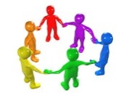 | PHSCE | Health and Wellbeing – Health and safety  Careers – Interview preparation, financial support for students
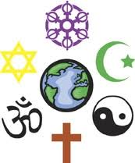 | RE | Is belonging an important part of the Human Experience?
 | Independent Living | Personal Care / Gathering Evidence for Portfolio
 | ASDAN  Construction | Health & Safety, Careers in Construction
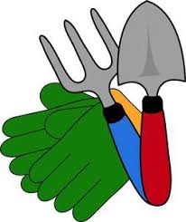 | ASDAN  Gardening | Gathering Evidence for Portfolio, Careers in Gardening
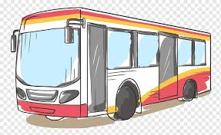 | Open Awards  Travelling Independently | Travelling independently on a chosen journey
 | Skills Builder | 11RS - Teamwork

