Ashley High School
Code of Conduct for School Governing Boards

Version
This code sets out the expectations on and commitment required from school governors, trustees and academy committee members in order for the governing board to properly carry out its work within the school/s and the community, It can be amended to include specific reference to the ethos of the particular school. Unless otherwise stated, 'school' includes academies, and it applies to all levels of school governance.
This code can also be tailored to reflect your specific governing board and school structure, whether that is as a maintained school or academy, either as a single school or group of schools. Where multiple options are given, i.e. senior executive leader/headteacher and governor/trustee/academy committee member, please amend to leave the option relevant to your governing board.
Once approved by the governing board, the Code will apply to all governors/trustees/academy committee members.
This Code should be read in conjunction with the relevant law and for academies, their articles of association and agreed scheme of delegation. It should be adapted as appropriate depending on the governance setting and level of delegation. However, its guiding principles should be retained regardless of the governance setting and level of delegation afforded to it.
The governing board has the following 3 strategic functions:
Establishing the strategic direction, by:
- Setting and ensuring clarity of vision, values, and objectives for the school(s)/trust
- Agreeing the school improvement strategy with priorities and targets
- Meeting statutory duties
Ensuring accountability, by:
- Appointing the lead executive/headteacher (where delegated)
- Monitoring the educational performance of the school/s and progress towards agreed targets
- Performance managing the lead executive/headteacher (where delegated)
- Engaging with stakeholders
- Contributing to school self-evaluation
Overseeing financial performance, by:
- Setting the budget
- Monitoring spending against the budget
- Ensuring money is well spent and value for money is obtained
- Ensuring risks to the organisation are managed
NGA recognises the following as the fourth core function of governance:
Ensure that other key players with a stake in the organisation get their voices heard by:
Gathering the views of pupils, parents and staff and reporting on the results.
- Reaching out to the school's wider community and inviting them to play their part.
Using the views of stakeholders to shape the school's culture and the underpinning strategy, policies and procedures.
As individuals on the board we agree to the following:

Role & Responsibilities
We understand the purpose of the board and its strategic role.
We understand how the role of the board differs from and works with others including the headteacher and where appropriate, executive leaders, trust boards and academy committees.
We accept that we have no legal authority to act individually, except when the board has given us delegated authority to do so, and therefore we will only speak on behalf of the governing board when we have been specifically authorised to do so.
We accept collective responsibility for all decisions made by the board or its delegated agents. This means that we will not speak against majority decisions outside the governing board meeting.
We have a duty to act fairly and without prejudice, and in so far as we have responsibility for staff, we will fulfil all that is expected of a good employer.
We will encourage open governance and will act appropriately.
We will consider carefully how our decisions may affect the community and other schools.
We will always be mindful of our responsibility to maintain and develop the ethos and reputation of our school/group of schools. Our actions within the school and the local community will reflect this.

In making or responding to criticism or complaints we will follow the procedures established by the governing board.
We will actively support and challenge the executive leaders.
We will accept and respect the difference in roles between the board and staff, ensuring that we work collectively for the benefit of the organisation.
We will respect the role of the executive leaders and their responsibility for the day to day management of the organisation and avoid any actions that might undermine such arrangements.
We agree to adhere to the school's rules and polices and the procedures of the governing board as set out by the relevant governing documents and law.
When formally speaking or writing in our governing role we will ensure our comments reflect current organisational policy even if they might be different to our personal views
When communicating in our private capacity (including on social media) we will be mindful of and strive to uphold the reputation of the organisation.
We will avoid, as far as possible, becoming involved in any communication which may lead to a conflict of interest with the role of the governing board.

Commitment
- We acknowledge that accepting office as a governor/trustee/academy committee member involves the commitment of significant amounts of time and energy.
We will each involve ourselves actively in the work of the governing board, and accept our fair share of responsibilities, including service on committees or working groups.
We will make full efforts to attend all meetings and where we cannot attend explain in advance why we are unable to.
We will get to know the school/s well and respond to opportunities to involve ourselves in school activities.
- We will visit the school/s, with all visits arranged in advance with the senior executive leader/
headteacher and undertaken within the framework established by the governing board.
When visiting the school in a personal capacity (i.e. as a parent or carer), we will maintain our underlying responsibility as a governor/trustee/academy committee member.
We will consider seriously our individual and collective needs for induction, training and development, and will undertake relevant training.
We accept that in the interests of open governance, our full names, date of appointment, terms of office, roles on the governing board, attendance records, relevant business and pecuniary interests, category of governor and the body responsible for appointing us will be published on the school's website.

In the interests of transparency we accept that information relating to governors/trustees/academy committee members will be collected and logged on the DfE's national database of governors (Get information about schools).

Relationships
We will strive to work as a team in which constructive working relationships are actively promoted.
We will express views openly, courteously and respectfully in all our communications with other governors/trustees/academy committee members, the clerk to the governing board and school staff both in and outside of meetings.
We will support the chair in their role of ensuring appropriate conduct both at meetings and at all times.
We will confront malpractice by speaking up against and bringing to the attention of the relevant authorities' any decisions and actions that conflict with the Seven Principles of Public Life (see annex) or which may place pupils at risk.
We are prepared to answer queries from other board members in relation to delegated functions and take into account any concerns expressed, and we will acknowledge the time, effort and skills that have been committed to the delegated function by those involved.
We will seek to develop effective working relationships with the executive leaders, staff and parents, the trust, the local authority and other relevant agencies and the community.

Confidentiality
- We will observe complete confidentiality when matters are deemed confidential or where they concern specific members of staff or pupils, both inside or outside school.
- We will exercise the greatest prudence at all times when discussions regarding school/trust business arise outside a governing board meeting.
- We will not reveal the details of any governing board vote.
- We will ensure all confidential papers are held and disposed of appropriately.

Conflicts of interest
We will record any pecuniary or other business interest (including those related to people we are connected with) that we have in connection with the governing board's business in the Register of Business Interests, and if any such conflicted matter arises in a meeting we will offer to leave the meeting for the appropriate length of time.

We accept that the Register of Business Interests will be published on the school/trust's website.
We will also declare any conflict of loyalty at the start of any meeting should the situation arise.
We will act in the best interests of the school as a whole and not as a representative of any group, even if elected to the governing board.
Ceasing to be a governor/trustee/academy committee member
We understand that the requirements relating to confidentiality will continue to apply after a governor/trustee/academy committee member leaves office
Breach of this code of conduct
• If we believe this code has been breached, we will raise this issue with the chair and the chair will investigate; the governing board will only use suspension/removal as a last resort after seeking to resolve any difficulties or disputes in more constructive ways.
Should it be the chair that we believe has breached this code, another governing board member, such as the vice chair will investigate.
Adopted by the governing board of Ashley High School, Widnes on the December 2019
Chair: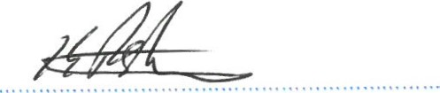Date: .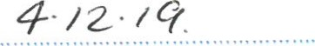
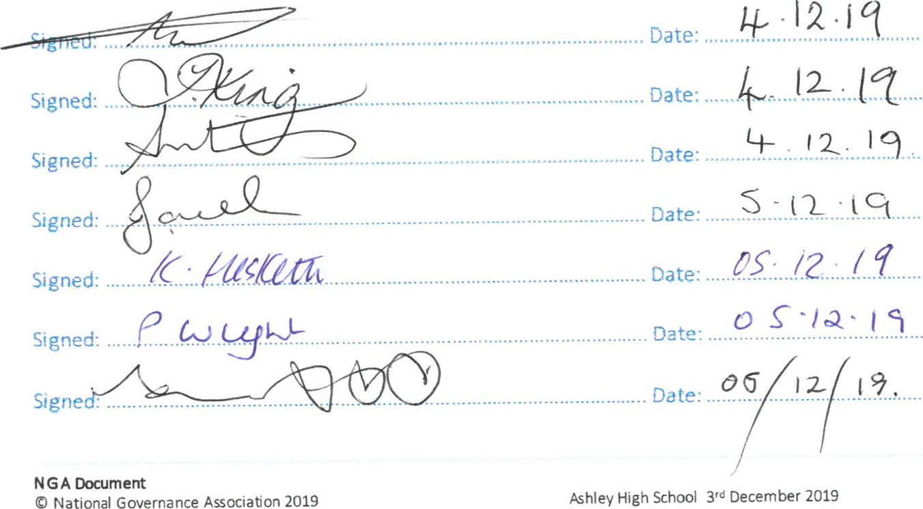
Signed:
Signed:
Signed:Date: .
Signed:
Signed: .Dale: .
Signed:. Date:
3

The Framework for Ethical Leadership in Education
The Ethical Leadership Commission has developed the following Framework for Ethical Leadership to help school leaders take difficult decisions. As important as the language is, these aren't just fine words, they are meant to support a culture in which ethical decision making can flourish.
- Selflessness School and college leaders should act solely in the interest of children and young people.
- Integrity School and college leaders must avoid placing themselves under any obligation to people or organisations that might try inappropriately to influence them in their work. Before acting and taking decisions, they must declare and resolve openly any perceived conflict of interest and relationships.
- Objectivity School and college leaders must act and take decisions impartially and fairly, using the best evidence and without discrimination or bias. Leaders should be dispassionate, exercising judgement and analysis for the good of children and young people.
- Accountability School and college leaders are accountable to the public for their decisions and actions and must submit themselves to the scrutiny necessary to ensure this.
- Openness School and college leaders should expect to act and take decisions in an open and transparent manner. Information should not be withheld from scrutiny unless there are clear and lawful reasons for so doing
- Honesty School and college leaders should be truthful.
- Leadership School and college leaders should exhibit these principles in their own behaviour. They should actively promote and robustly support the principles, and be willing to challenge poor behaviour wherever it occurs. Leaders include both those who are paid to lead schools and colleges and those who volunteer to govern them.
Schools and colleges serve children and young people and help them grow into fulfilled and valued citizens. As role models for the young, how we behave as leaders is as important as what we do. Leaders should show leadership through the following personal characteristics or virtues:
  - Trust: leaders are trustworthy and reliable
We hold trust on behalf of children and should be beyond reproach. We are honest about our motivations.
  - Wisdom: leaders use experience, knowledge and insight
We demonstrate moderation and self-awareness. We act calmly and rationally. We serve our schools and colleges with propriety and good sense.
  - Kindness: leaders demonstrate respect, generosity of spirit, understanding and good temper
We give difficult messages humanely where conflict is unavoidable.
  - Justice: leaders are fair and work for the good of all children
We seek to enable all young people to lead useful, happy and fulfilling lives.
e. Service: leaders are conscientious and dutiful
We demonstrate humility and self-control, supporting the structures, conventions and rules which safeguard quality. Our actions protect high-quality education.
f. Courage: leaders work courageously in the best interests of children and young people
We protect their safety and their right to a broad, effective and creative education. We hold one another to account courageously.
g. Optimism: leaders are positive and encouraging
Despite difficulties and pressures, we are developing excellent education to change the world for the better.

