YEAR 9 |  | Summer
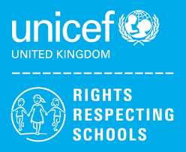 | Rights of the Child | Article 29 (goals of education) Education must develop every child’s personality, talents and abilities to the full. It must encourage the child’s respect for human rights, as well as respect for their parents, their own and other cultures, and the environment.
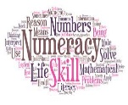 | Numeracy | Money
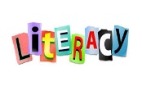 | Literacy | Homophones
 | English | 9AK & 9KD Shakespeare: Romeo & Juliet
 | Maths | 9KD – Number, Algebra, Ratio & Proportion, Geometry & Measures, Probability, Statistics  9AK – Lines and Angles, Measures, Factors and Multiples
 | Science | GCSE: Organisation, Bonding, Electricity  ELC Energy Forces and structure of matter
 | Computing/ICT | Spreadsheet Modelling – Harry Plotter, Scratch Programming Software
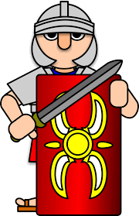 | History | Halton Through History  (Local History unit)
 | MFL | French: All About Me, Family
 | Geography | Rivers, Weathering and Erosion, Geography investigations
 | P.E. | Tag Rugby, Athletics,  Rounders, Tennis
 | Design Tech | Mechanical toy, Jigsaw puzzle
 | Food Tech | 9KD– Individual Cooking Skills / Food Poisoning
 | Art | Indian Art, Presentation Skills
 | PHSCE | Health and Wellbeing – managing peer pressure  Living in the wider world , Career Talk
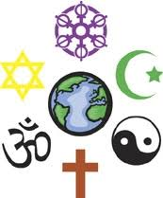 | RE | Who Inspires us?  Sacred texts and teachings
 | Music | Popular music  Musical vocabulary
 | Independent Living | First Aid  Interpersonal Skills
 | Skills Builder | 9AK Teamwork  9KD - Teamwork

