Here is some information about grief and bereavement in connection with Coronavirus
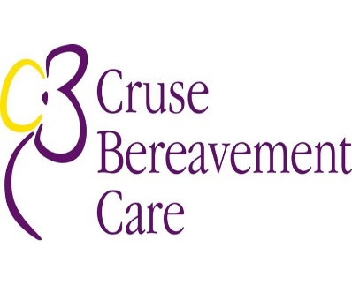
https://www.cruse.org.uk/get-help/coronavirus-dealing-bereavement-and-grief
These resources have been put together to share how bereavement and grief may be affected by this pandemic. It covers some of the different situations and emotions bereaved people may have to deal with.
North West Boroughs Health Care NHS Trust have launched a crisis line to provide support 24 hours a day, seven days a week to people of all ages including children and young people who need urgent mental health support.
The Crisis line is first port of call for Halton residents experiencing a mental health crisis
01928 275 309

Halton’s Mental Health Info point
www.halton.gov.uk/mhinfopoint

