YEAR 13 |  | Summer
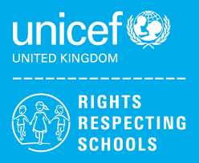 | Rights of the Child | Article 29 (goals of education) Education must develop every child’s personality, talents and abilities to the full. It must encourage the child’s respect for human rights, as well as respect for their parents, their own and other cultures, and the environment.
 | English | Exam Skills and Revision
 | Maths | Level 1 / Entry 3 – Maths skills qualification – Students will study a selection of modules from Number, 2D Shapes, Measures  Level 1 - Managing Personal Finance - Bank & building society products, Advantages & disadvantages of borrowing money
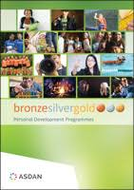 | CoPE/YAS | Developing and demonstrating a range of personal skills by completing a choice of modules from the following:  Communication; Citizenship and Community; Sport and Leisure; Independent Living; The Environment; Vocational Preparation; Health and Fitness; Work Related Learning and Enterprise; Science and Technology; International Links; Expressive Arts; Beliefs and Values (RE)
 | Employability Level 1 | Dealing with Customer Queries and Complaints / Gathering Evidence for Portfolio
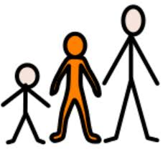 | Preparing for Adulthood | Health & Wellbeing/Travel/Work Experience

