YEAR 7 |  | Summer
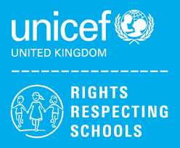 | Rights of the Child | Article 29 (goals of education) Education must develop every child’s personality, talents and abilities to the full. It must encourage the child’s respect for human rights, as well as respect for their parents, their own and other cultures, and the environment.
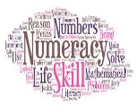 | Numeracy | Money
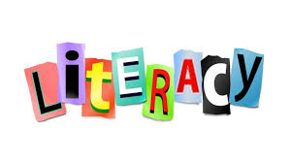 | Literacy | Homophones
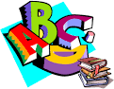 | English | Writing: Transactional and Creative Writing  7SA: Balanced Arguments, Non-Fiction writing (magazine writing)  7JPF: Letter writing (Formal and informal) Narrative Writing (picture stimulus)  7LA- Narrative writing, short stories, character profiles
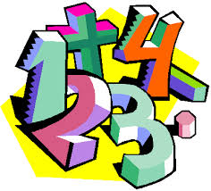 | Maths | 7JPF: Place Value, Fractions, Decimals, Money, Time, Shape and Measures  7SA: Angles + Lines, Measuring + Shapes, Fractions, Decimals, Percentages, Transformations  7LA:Direction and position, data handling, pictograms and bar charts
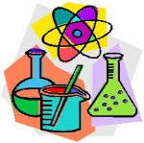 | Science | Sexual Reproduction in Animals, Ecosystems,  Forces & Sounds  Plants and growing
 | Computing/ICT | Spreadsheet Modelling,  Using Datasets
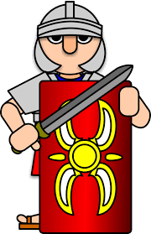 | History | Medieval Britain
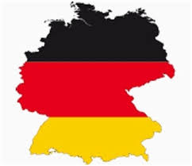 | MFL | German:  die Schule  (School)
 | Geography | Population and settlement
 | P.E. | Rounders, Tag Rugby, Athletics, Tennis
 | Design Tech | Coat hook, Ball bearing game
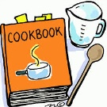 | Food Tech | 7LA – Healthy Eating/Baking
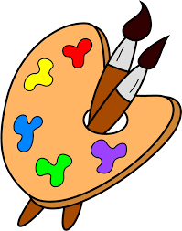 | Art | Landscapes & Illustration
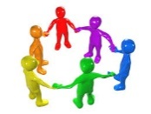 | PHSCE | Health and Wellbeing – managing puberty + consent
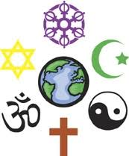 | RE | Where do people connect with God?
 | Music | The Elements of Music
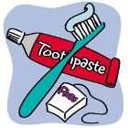 | Independent Living | Food Management  Housekeeping  Health  Knowledge of Community Resources
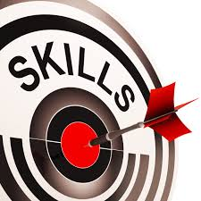 | Skills Builder | Key Skills – Creativity

