YEAR 10 |  | Summer
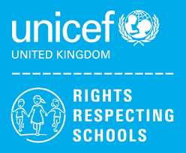 | Rights of the Child | Article 29 (goals of education) Education must develop every child’s personality, talents and abilities to the full. It must encourage the child’s respect for human rights, as well as respect for their parents, their own and other cultures, and the environment.
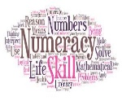 | Numeracy | Money
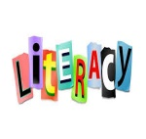 | Literacy | Homophones
 | English | 10L –Step Up Component – Reading and Writing Fiction  10L – Functional Skills - Writing  10GG – Revision Paper 1. Mock Examination.
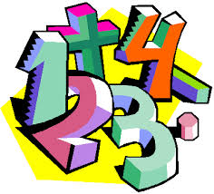 | Maths | 10GG – Number, Algebra, Geometry & Measures, Ratio, Probability, Statistics  10L – Addition + Subtractions Skills, Fractions, Complete coursework
 | Science | GCSE: Atomic Structure, Inheritance Variation and Evolution, Rate and Extent of Chemical change, Forces  ELC: Electricity, Electromagnetism , Waves
 | Computing/ICT | 10GG – EdExcel ICT Functional Skills Level 2 exam preparation  10L – WJEC Entry Pathways Modules – Presentation Software, Spreadsheet Software
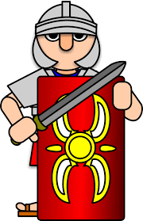 | History | GCSE- Germany 1890-1945: Democracy and Dictatorship
 | Humanities | Being A Tourist In A French Speaking Country
 | P.E. | Athletics/Tag Rugby  Striking and fielding
 | Food Tech | Home Cooking Skills  BTEC Level 1  Passing on information & staple foods
 | Creative Media | Film studies  Preparing work for moderation
 | PHSCE | Relationships and Sex education  Careers – what makes you tick personality test and job values
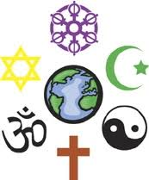 | RE | Contentious Issues in the Modern World  Peace and Conflict
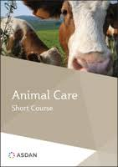 | Animal Care | Asdan- Short Course-  Animals In Trouble
 | Preparation for work | WJEC - Practical project – Storage unit
 | Duke of Edinburgh | Section 4 - Preparation for Expedition  Expedition – Overnight camp
 | Skills Builder | 10L - Teamwork

