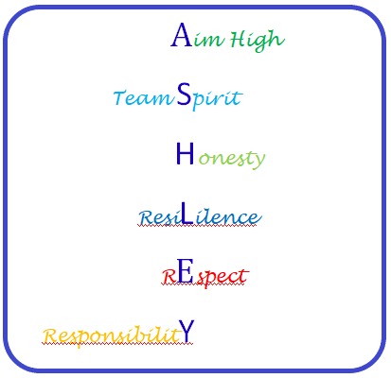**6th Form Behaviour System**

# **Rewards for positive behaviours**

Earn up to 2 credits per lesson for:-

1. Work Ethic
2. General attitude

Also earn a credit at break and a credit at lunch for:-

1. General attitude

Credits start on a Monday and end on a Friday.

Students can earn up to 76 credits per week.

Credits earn rewards that are organised at the end of each half term

|  |  |  |
| --- | --- | --- |
| Type of reward | How many credits needed | Time gained |
| GOLD | 70+ | Wed (End of each half term) - Lesson 4, 5 & 6 off timetable and choice of activity  *\*\* Independent travellers can go home* |
| SILVER | 60 - 69 | Wed (End of each half term) - Lesson 5 & 6 off timetable and choice of activity  ** *Independent travellers can go home* |
| BRONZE | Below 60 | Wed (End of each half term) - Lesson 6 off timetable and choice of activity  ** *Independent travellers can go home* |

Additional rewards

* Individual quick notes
* Positive phone calls, texts or emails home
* Personal achievement awards in assembly

**Each term is a fresh start and credits are restarted so that you can aim higher each term!**

