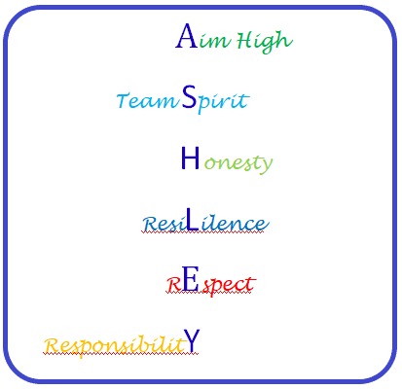 **Behaviour System**



# **Rewards for positive behaviours**

Earn up to 2 credits per lesson for:-

1. Work Ethic
2. General attitude

Also earn a credit at break and a credit at lunch for:-

1. General attitude

Credits start on a Monday and end on a Friday.

Students can earn up to 76 credits per week.

Credits earn rewards that are organised in class by the form tutor.

This will be given Lesson 6 on a Friday!

|  |  |  |
| --- | --- | --- |
| Type of reward | How many credits needed | Time gained |
| GOLD | 70+ | Whole lesson |
| SILVER | 60 - 69 | Last 30 minutes of lesson |
| BRONZE | Below 60 | Last 15 minutes of lesson |

Additional rewards

* Individual quick notes
* Positive phone calls, texts or emails home
* Personal achievement awards in assembly

**Each term is a fresh start and credits are restarted so that you can aim higher each term!**